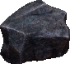

**The Ringed City**



Quest: Defeat a Demon, reward: -5 cost.

: +1 DEF per turn.

: +1 Max HP per turn.

Mythical: +1 ATK.



